**Mrs. Griffith**

**4th Grade ELA**

**Saint Teresa of Calcutta**

**Required Book Report Schedule**

This year in fourth grade you will be expected to complete a series of book reports. A different style book report will be due each trimester. I am assigning them to you in advance so that you are aware of my expectations and can choose your books ahead of time. Please remember to use your study skills and not procrastinate! The rubrics for each report are included on the pages that follow. All assignments must be written (not typed). Happy reading! ☺

C:\Users\Owner\AppData\Local\Microsoft\Windows\Temporary Internet Files\Content.IE5\BUMF5LX3\MC900440424[1].wmf

**-Report 1- Book in a Bag Report-** Choose a biography or autobiography.Instructions and a rubric are included on the following pages. ***DUE OCTOBER 27th***

**-Report 2- Comic Strip Report-** Choose a fantasy or mystery novel. Instructions and a rubric are included on the following pages. ***DUE JANUARY 26th***

**-Report 3- Story Cube Book Report-** Any genre you choose! Instructions and a rubric are included on the following pages. ***DUE APRIL 6th***

**Genre Descriptions**

**Fiction Genres:**

* Fairy Tales- Fairy tales are “make believe” stories written for children that tend to involve magic. The characters are often elves, goblins, dragons, fairies, or other magical creatures.
* Fantasy- Fantasies are imaginative stories dealing with supernatural or unnatural events or characters. Creatures may be in the stories that do not exist in real life. There is often a struggle between good and evil.
* Fable- Fables are short stories with animal characters that act like humans. There is a lesson or moral to be learned from each story.
* Mystery- Genre whose plot involves a crime or other event that remains puzzlingly unsettled until the very end. A mystery may have a detective or spy as the main character. Clues are used by characters to find a solution.
* Historical Fiction- Some characters may be real and others are fictional. This story takes place during a period in history.
* Realistic Fiction- A story with fictional characters that behave in realistic ways.
* Science Fiction- Literary genre in which a background of science is an important part of the story. Many of the events recounted in a science fiction story could take place within the future, such as robots or space travel.

**Nonfiction Genres:**

* Informational- Intended for teaching and informational purposes. They include true facts and information on all types of different subjects.
* Biography- A written account of the life of a real person. The author is a different person than who the book is about. The author describes how the person’s life affected others.
* Autobiography- A written account of the life of a real person written or told by that person.

**Book Report #1**

**Book in a Bag Report**

**Due Date: October 27th**

For this report you will be creating a bag that represents the life of a real person. You may choose a biography or autobiography (see genre descriptions for reference). Follow the example bag below to construct your report. Be ready to present to the class!

C:\Users\Owner\AppData\Local\Microsoft\Windows\Temporary Internet Files\Content.IE5\L6274VH2\MC900297833[1].wmf

**Inside the bag:**

**-The book**

**-Place four items that symbolize/represent your person**

**Right Side:**

**Describe the items in your bag and how they represent or symbolize your person. (one sentence per item)**

**Front:**

**-Person’s Name**

**-Date of Birth-Date of Death**

**-Picture of the Person**

**Back:**

**-Title of Book/Author**

**-What did your person accomplish? Why is he/she so important? (one paragraph)**

**Left Side:**

**-What have you learned about your person’s childhood? (one paragraph)**

**-What are some interesting facts about this person? (one paragraph)**

**Book in a Bag Report Rubric**

Name:_______________________________________________

|  |  |  |
| --- | --- | --- |
| Book in a Bag Book Report | Points Possible | Points Earned |
| Overall neatness of the bag | 5 |  |
| Back- What did your person accomplish? Why is he/ she so important? (one paragraph)  Title of the book/author | 25 |  |
| Left Side-Write what you have learned about the person’s childhood. (one paragraph)  Write some interesting facts about this person. (one paragraph) | 20 |  |
| Right Side- Describe the items in the bag and how they symbolize/represent your person. (one sentence per item) | 20 |  |
| Inside the Bag- Include the book and four items that symbolize or represent your person. | 20 |  |
| Front-Include the person’s name, their date of birth-date of death, and a picture of the person. | 10 |  |

*Each section will be graded for completion, understanding of the person, spelling, capitalization, grammar, and punctuation.

**Book Report #2**

**Comic Strip Book Report**

**Due Date: January 26th**

For this book report you will create a nine-panel comic strip (including the title box) based on **part** of a mystery or fantasy novel that you read. Your comic strips will include illustrations as well as text. Feel free to look at real comic strips for ideas. Be sure to use neat handwriting, add color and pictures, and edit for spelling and grammatical errors. Have fun!

[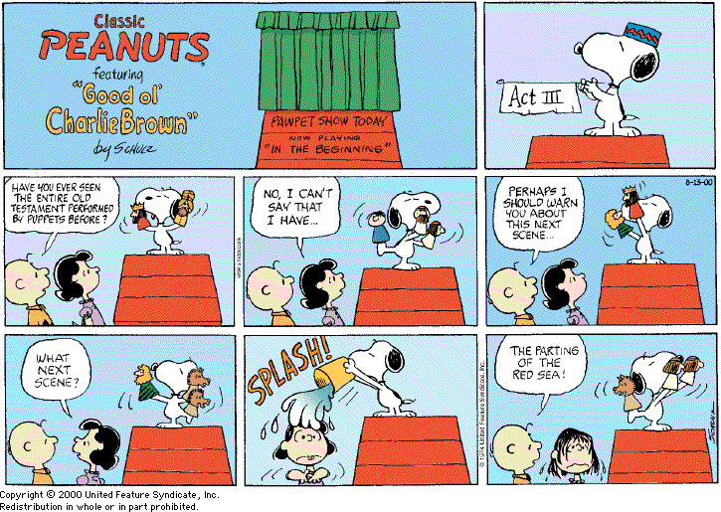](http://www.google.com/url?sa=i&rct=j&q=&esrc=s&frm=1&source=images&cd=&cad=rja&docid=PLk9jooZqyshBM&tbnid=aY0tWf40aFfTtM:&ved=0CAUQjRw&url=http://gatheringbooks.wordpress.com/2010/09/07/on-graphic-novels-comics-and-picture-books-a-talk-by-janet-evans/&ei=0hYlUtOvPPO34AOm0oCYDg&bvm=bv.51495398,d.cWc&psig=AFQjCNGm0dXj3SlL_2noIM3yxKCbv0YwZw&ust=1378248782576073)

Directions:

1. Find a mystery or fantasy book that is appropriate for your reading level (check the genre sheet for reference).
2. Choose an important or exciting part of the book that you would like to retell in your comic strip. The part you choose should allow you to include ***action and dialogue***. Please write a two-paragraph summary of this part of this book. Remember, each paragraph should have at least five sentences! Glue the summary in the center on the back of the white construction paper or poster board that you use for your comic strip.
3. Use your summary as you sketch your comic strip. Decide what you will include in each panel. Your comic strip will have a total of nine panels-eight panels with pictures and one panel for the title. The title panel should include your name, title of the book, and author’s name. Please make sure that the sequence of events is clear and easy to follow!
4. Position a sheet of white construction paper or poster board horizontally and make nine boxes that are about equal in size. Some boxes may need to be larger or smaller depending on what will be in them. Draw and write in pencil first then go over your text and illustrations with pen or thin markers. Try to keep it as neat as possible. When finished, color your strip with colored pencils.

**Comic Strip Rubric**

|  |  |  |
| --- | --- | --- |
|  | Possible Points | Points Earned |
| The comic strip is on white construction paper or white poster board. | 5 |  |
| The student chose an exciting part of the book to retell. | 10 |  |
| A two paragraph summary was included on the back. | 15 |  |
| The comic strip included nine panels and dialogue between different characters. | 5 |  |
| The comic strip effectively retold the part of the book. | 30 |  |
| The comic strip included illustrations and text. | 10 |  |
| The comic strip was neat and easy to follow. | 15 |  |
| The report was free of spelling, punctuation, and grammatical errors. | 10 |  |
| Total Points | 100 |  |

**Book Report #3**

**Story Cube Book Report**

**Due Date: April 6th**

For this book report you are going to make a story cube that explores six different topics of a book that you select (it can be any genre). All sides need to be written neatly in cursive or print (no typing). The sides will focus on:

1. Title & Author

2. Setting

3. Main Character

4. Favorite Part

5. Summary

6. Recommendation

Title & Author- Write the title of the book and the author’s name. Be sure to also include a picture that represents the book and/or any awards the book might have received.

Setting- Draw a picture of what the main setting looks like as described in the book.

Write 3 sentences describing this setting.

Main Character- Decide who the main character is in the book (if there is more than one, just choose one), and write their full name on the top of this side. In bulleted statements, list 4 phrases/words to describe him/her. These can include physical characteristics and personality traits. Finally, draw one picture to go along with your phrases or what you think the character looks like.

Favorite Part- Draw a picture of your favorite part of the book. In one complete sentence, explain what your favorite part is and why.

Summary- Write one paragraph that describes how the book begins, what the main events are, and how the book ends. Be sure to check your grammar and your spelling. Remember that a paragraph includes at least five sentences!

Recommendation- Rate how good the book was by drawing the appropriate number of stars, on a scale of 1-5 with 5 being the best. Then write a paragraph describing the rating and why you chose it. Be sure to include the name of the book and its rating in the topic sentence. The body should support your rating with details from the book.

End the paragraph by stating if you would recommend the book, and why or why not.

Be sure to check your grammar and spelling.

To construct your story cube you may use an old cardboard or tissue box, print the attached template onto cardstock, or trace the template onto poster board for durability. Good luck!

Name ______________________________________________________

Story Cube Grading Rubric

Title & Author

* Title & Author are neat and spelled correctly _____/3
* Illustration is neat, uses color (coloring pencils or crayons) _____/3
* Name and date _____/3

Setting (time & place)

* Illustration is neat, uses color (coloring pencils or crayons) _____/3
* Description of setting (3 sentences) _____/3
* Text is neat and legible _____/2
* No grammar or spelling errors _____/4

Main Character

* Full name- accurate (on top) _____/3
* 4 phrases (important information about character) _____/8
* Illustration is neat, uses color (coloring pencils or crayons) _____/4
* Writing is neat and legible _____/2
* No grammar or spelling errors _____/4

Favorite Part

* Illustration is neat, uses color (coloring pencils or crayons) _____/3
* Writing (1 sentence) tells what it is and why _____/5
* Writing is neat and legible _____/2
* No grammar or spelling errors _____/4

Summary

* 1 Paragraph of 5-7 sentences _____/5
* Topic sentence: What happens at the beginning of the book _____/2
* Body (details): What happens in the middle of the book _____/6
* Closing sentence: What happens at the end of the book _____/2
* Writing is neat and legible _____/2
* No grammar or spelling errors _____/4

Recommendation

* Star rating: rates book on a 1-5 star scale with 5 being the best _____/2
* 1 Paragraph of 5-7 sentences _____/5
* Topic sentence: States the name of the book & rating _____/2
* Body (details): Explains rating, what was liked/not liked, lesson learned ____/6
* Closing sentence: Would you recommend the book & why? _____/2
* Writing is neat and legible _____/2
* No grammar or spelling errors _____/4

TOTAL POINTS--------------------------------------------------------_______/100

[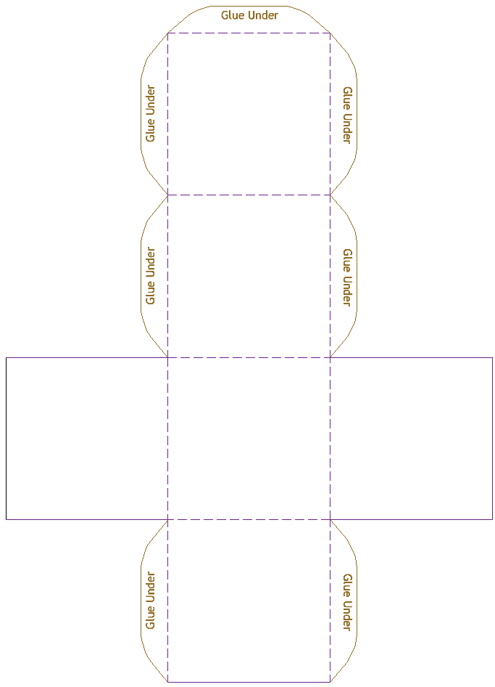](http://www.google.com/url?sa=i&rct=j&q=&esrc=s&frm=1&source=images&cd=&cad=rja&docid=8h04SAc1oaFtwM&tbnid=mv5VsVPd1hpLiM:&ved=0CAUQjRw&url=http://www.mathsisfun.com/geometry/cube-model.html&ei=hC8lUtXXEYzl4AOYyYDwBw&bvm=bv.51495398,d.cWc&psig=AFQjCNHdS4pBXOY_d_0BUhO2JgIhDht0Cw&ust=1378255050263631)