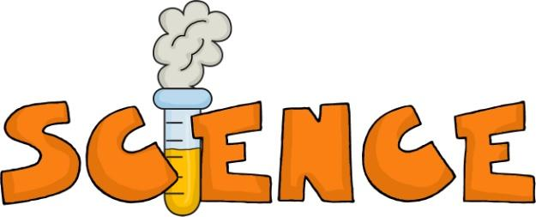
Dear Parents,
I wanted to let you know that we are beginning our unit on chemistry. We will do one investigation per week. All of the terms for the entire unit as well as PowerPoints and great resources are posted on my website. I will also send home a hard copy of the terms. The students will have a chemistry project due Friday, February 10. Students have to do a chemistry experiment at home and write a brief summary (5-8 sentences) explaining what they did. The students need to make sure they explain the chemical reaction happening in the experiment. The summary needs to be written and not typed. A picture of the experiment must be taken so students can share this with the class. It would be great if you could email me the picture so I can put it on the SmartBoard during the presentation. Students can also bring in the experiment instead of a picture (if it is small-no volcanoes☺) If the chemistry experiment does not work the first time, students do not have to do it again. It is fine with me if the students just say the steps they took in the experiment and bring in/email a picture of the experiment or bring in the actual experiment. They can also say what the experiment was supposed to look like. Sometimes experiments do not work for a variety of reasons, so it’s a good learning experience for them. If you make a movie, you will need to create a YouTube or Vimeo link and then email me the link.
It is VERY important that students do this experiment with an adult. We do not need any accidents, injuries or fires. I attached some ideas of simple experiments students can do, but they can do other things too. I think students will be eager to do this, so they can bring it in early to present. The rubric is on the back of this letter.
Thank you,

Mrs. Griffith

