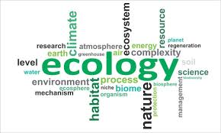

Ecosystem Rubric

You followed directions as specified (50 points) ___________
in the assignment.

You put effort into the (30 points) ___________
project and you put your name on it.

The project was turned in on time (20 points) ___________
and you used correct spelling
and grammar.

Total Science Grade __________________

