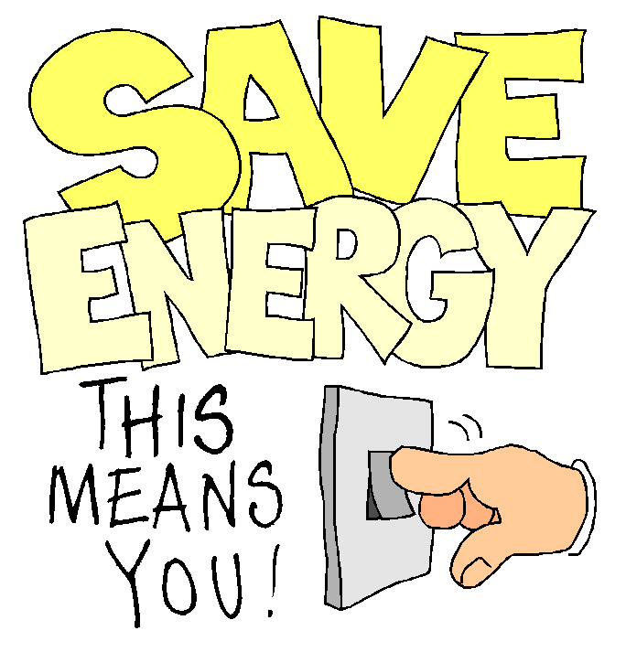
For the last science project of the year the focus will be energy conservation. Students need to make either a poster (any size), an advertisement, a mobile or a book showing at least 5 ways people can save energy. If you are doing the advertisement, you can do a storyboard (one frame for each of the 5 ways people can save energy) and actually perform the commercial for the class. If you have any other creative idea, you can ask me. I just want to make sure you can do it all by yourself. The theme of saving energy needs to be evident in the project. This project is due on Earth Day which is Wednesday, April 22.
The grade will be based on following directions for this project as well as putting effort into the project. All artwork must be drawn by students. Clip art cannot be used. All work is to be done 100% by students. Another person cannot outline the picture for you. Students will not receive a passing grade if any part of this project is done by another person. The project needs to clearly show 5 ways that a person can save energy. Students will present this project to the class. Points will be taken off for late projects.

